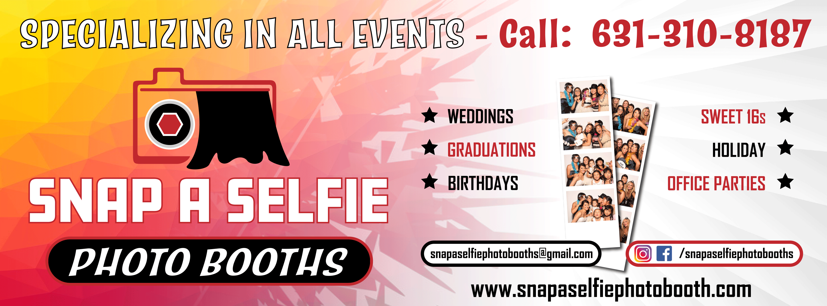

Snap a Selfie Photo Booths has been providing photo booth entertainment for the last
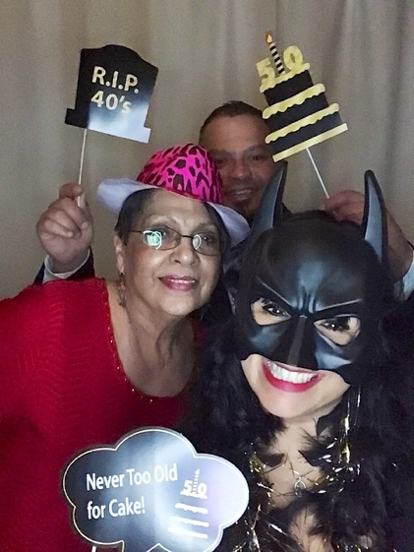
10 years. We specialize in all events! Weddings, Engagement parties, Sweet 16, Holiday parties, Graduation parties and much more! We offer a wide range of photo booth packages to fit your budget and entertainment needs!
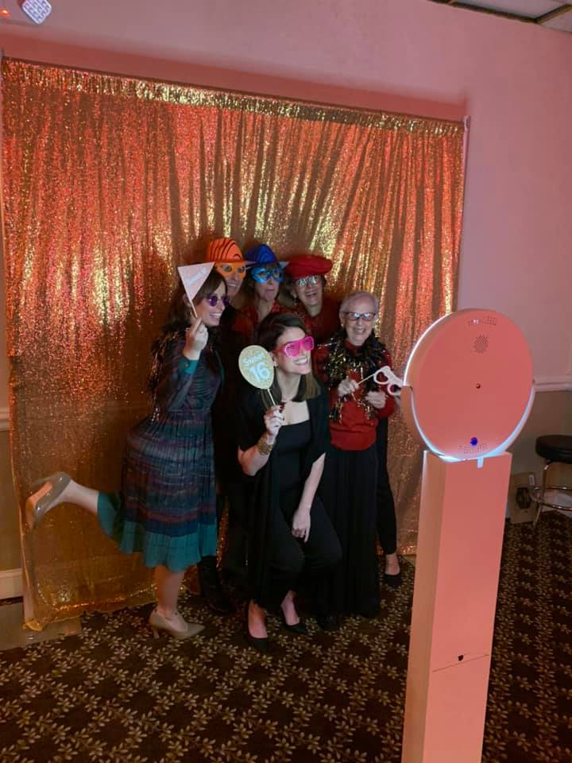
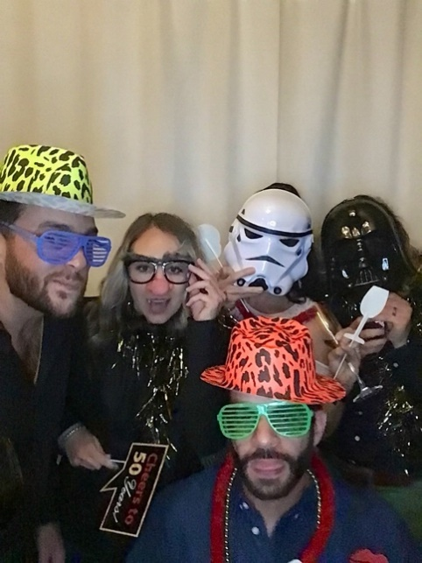

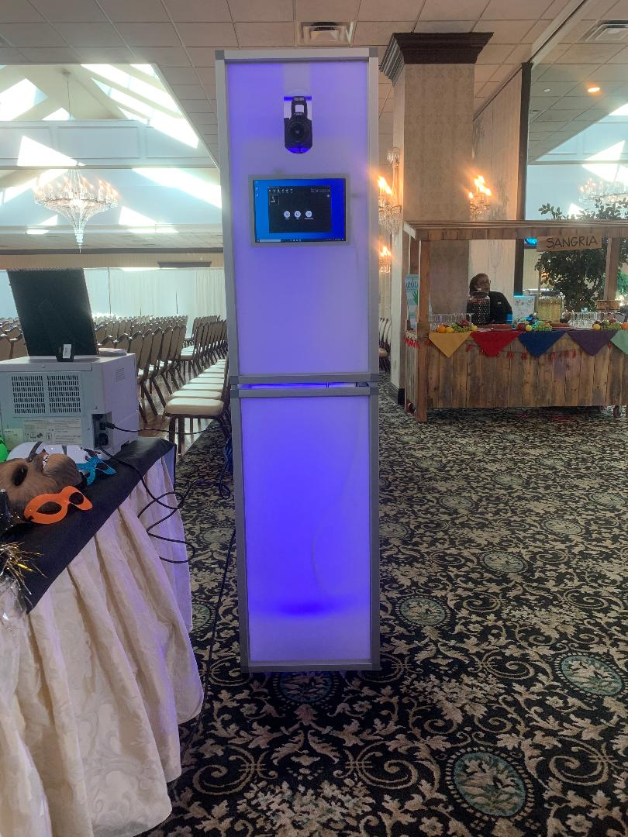

PHOTO BOOTH PACKAGES

Share and Print Bronze Package
3-4 hours of booth time
Social media and SMS sharing
Unlimited Props
Unlimited Prints
Link to album
Two Photo booth assistants

Helio Ring Photo Booth- $500
LED Photo Booth- $600

Share and Print Silver Package
4-5 hours of booth time
Choose your own custom backdrop
Social media and SMS sharing
Unlimited Props
Unlimited Prints
Scrap Book
Link to Album
Two Photo booth assistants

Helio Ring Photo Booth- $600
LED Photo Booth- $700

Share and Print Gold Package (MOST POPULAR)
4-5 hours of booth time
Inflatable LED housing for booth
Step & Repeat
Social media and SMS sharing
Unlimited Props
Unlimited Prints
Scrap Book
Link to album
Two photo booth assistants

Helio Ring Photo Booth- $900
LED Photo Booth- $1200

